**INTRODUCTION**

**CHAPTER 1**

**INTRODUCTION**

Android application have shown a dramatic improvement in their functionality to a point where it is now possible to have cellular phone execute Java programs. As a result, cellular users throughout the world are now able to read and write email, browse web pages and play java games using their cellular phones. This trend has promoted as to propose the use of android application for better communication. Before SMS/MMS, deaf people rarely used mobile phones. Mobile video chat may one day replace texting, but only for conversations between hearing callers, not for those between deaf and hearing callers. Outfit-7 is an application in which an image movement will repeat everything we say in a high-pitched voice. Without dialing number we can use this application.

**1.1 OVERVIEW OF THE PROJECT**

Our project isan alternative for gesture detection using image processing technique between deaf people which overcomes the above technique and paves the way for the communication between deaf and normal people in their daily activities using sign language and video relay service. Video technology continues to improve and one day may be the preferred means of mobile communication among the deaf. It allows deaf, hard-of-hearing and speech impaired individuals to communicate over video or other technology with hearing people in real-time, via a sign language interpreter. The idea behind SE (Signed English) and other signing system parallel to English is the deaf people will learn English better if they are exposed.The sign language provides video by improving small-screen mobile communication among the deaf. There are mainly three parts:

* Speech-Recognition Engine
* Database and
* Recognized Text

Under Speech- Recognition Engine we include Sign to Speech with Outfit – 7 and Video Relay Service (VRS - enables audible language translation on smart phones with signing) technologies and Speech to Sign using Mimix technology.

**1.2 GOAL OF THE PROJECT**

The goal of this project is to determine gesture recognition that might enable the deaf to converse with the hearing people remotely and is done by a JSON interpreter. We are not aware of any research which aim is to provide un-intermediated mobile communication between deaf and hearing people, each conversing using their own natural languages. Hence our project has provided the idea of implementing communication between deaf and hearing people in day-to-day life. Initially, mobile search functionality must recognize either ASL (American Sign Language) Text or voice and convert it to both text message as well as video for relevant input. ASL2TXT enable sign language finger spelling communication (signs displayed in the keyboard) take text and display video.

The process abounds the following:

* A deaf person signs
* Software translates signs into text (and video)
* The hearing person reads it (and view it)
* The hearing person and deaf people speaks into microphone
* Software translates voice into text (and ASL video)
* The deaf person reads it (and sees ASL video)

**1.3 FEATURES OF THE PROJECT**

* Without dialing number we can communicate to other like face to face communication.
* It does not require large amount of storage as it uses the Hand speak support through online.
* The sign words are signed in the same order as letters appear in English alphabets.
* This project prepares individuals to work as interpreter/translators facilitating and mediating communication between Deaf/Hard of Hearing and hearing people.
* Accurate and appropriate transfer of a message from a source language into a target language from the point of view of style and culture

**1.4 DOMAIN INTRODUCTION**

Since all deaf are not using sign language in their day to day life, for ease of exposition, we define the term “deaf” broadly, to include any person who communicates primarily using American Sign Language (ASL). Some hearing people use both audible and sign languages, we use the term “hearing” to suggest a person who speaks in audible language and does not sign. Technical literature uses the term “translation” in favor of “interpretation,” So we follow the standard for that reason. Sign language interpreter is responsible for helping deaf or hearing impaired individuals understand what is being said in a variety of situations. An interpreter must understand the subject matter so he or she can accurately translate what is being spoken into sign language Interpreters may also be used in one-on-one situations; they might use technology to provide services from a remote location.

**1.5 VIDEO-RELAY SERVICE**

Deaf callers can also contact hearing parties through interpreters using mobile video chat through smart phones, tablet PCs, or iPods with Wi-Fi connection, but these solutions still require human interpreters. But in to overcome this Free sign language resources and extracurricular materials for language enthusiasts, ASL students and learners, instructors and teachers, interpreters, homeschoolers, parents and professionals who are interested in [learning how to sign language](http://www.handspeak.com/lesson/index.php?byte=general) online and/or beyond classes for practice or self-study. This is achieved by using the resource hand speak implemented along with the JSON technique. Video of ASL is available at various websites, such as ASL Pro Michigan State University’s ASL Browser and Signing Savvy. Users access video by typing their text-string identifiers. ASL2TXT requires a **reverse ASL Dictionary**, one which allows users to gesture signs, then read text translations, or listens to audio translations.

**SYSTEM ANALYSIS**

**CHAPTER 2**

**SYSTEM ANALYSIS**

The purpose of the System Analysis is to produce the brief analysis task and also to establish complete information about the concept, behaviour and other constraints such as performance measure and system optimization. The goal of System Analysis is to completely specify the technical details for the main concept in a concise and unambiguous manner.

**2.1 EXISTING SYSTEM**

* Communication through cell (with dialling number)
* Face to face communication (without dialling number).

COMMUNICATION THROUGH CELL

This happens only between caller and callie as they communicate only through dialling number. It may be preferable at times to go to the cloud for image search, analysis and translation into text/voice, depending on the processing power of the mobile devices, the resolution of the images and the size of the vocabulary database. However, satisfactory results have already been reported as an issue. It can be used only between the caller and Callie.

FACE TO FACE COMMUNICATION

Today a new option is available for a conversation with each other it’s a new app called Mimix. Anything a person will say is immediately translated to sign language through Mimix making it easier to have a clear, two-way communication with a deaf without having to know sign language. It works based on recorder. The limitation in MIMIX Application is to convert the normal language into sign. Recording is done by clicking convertor button to convert to sign language. By cause of this it takes time.

**2.2 PROPOSED SYSTEM**

Using this application we paved a way for the deaf person who can easily interact with normal person anywhere. This project also supports Automatic translation, automotive speech recognition, and Speech-to-sign transmission. Our proposed system includes a variety of technologies. It consist two main parts hardware and software. In hardware parts we required phone, speaker. In software we mainly consider outfit-7 (which is used in tomcat application) and Video Relay Service (VRS). All these parts can be brought together in an integrated system. In this system we implement outfit-7 in VSR application. Outfit-7 is an application for the mobile phone, with the software, which will convert everything we say in a high pitched voice. Without dialling number we can use this application.

The main important way for communication between deaf has been implemented in our project; it is nothing but ASL (American Sign Language). All letters are signed using only the right hand which is raise with the palm facing the viewer. SE (Sign English) is a reasonable manual parallel to English. The idea behind SE and other signing system parallel to English is the deaf people will learn English better if they are exposed. SE uses two kinds of gesture: Sign Words, and Sign Markers.

Each Sign word stands for a separate entry in a Standard English dictionary. In our project we implement the Sign Word concept, which is useful in conversion of Sign Language into words. Most of signs in SE are taken from ASL. But these signs are now used in the same order as English words and with the same meaning. By using this application deaf person can easily interact with normal person anywhere, and he can also use this application for mobile sign translation using VSR and by using UTF-7 he can communicate in daily activates without dialling number.

MODULE DESCRIPTION

* Login
* Sign to Text (or) Sign Recognition
* Access ASL Dictionary
* Sign Language Recognition

**2.3 LOGIN**

This module is used to help the user to install the application in their mobile phones. Once the user installs the application it asks the user to enter their user name, password and confirm password. If both the password matches the user registration gets successful now the user is taken to the page where the ASL keyboard is displayed.

The user can view their details using SQLite browser database. The result is the creation of virtual application environment on the user’s machine with the bare minimum of application components streamed into it. This application is a self - contained application .In effect, the interface to the users application becomes completely mobile where ever suitable network connectivity exists, the user can access their own personal application, and the state of these application is preserved between accesses from different locations.

Database

**LOGIN**

1 Username

2 Passwords

3 Confirm Password

*Fig. 2.3 Login*

**2.4 SIGN TO TEXT**

Second module comprises the Sign Language input, which is displayed as the keyboard on the mobile screen. **American Sign Language** (**ASL**) is the predominant [sign language](http://en.wikipedia.org/wiki/Sign_language) of [deaf communities](http://en.wikipedia.org/wiki/Deaf_community) in the [United States](http://en.wikipedia.org/wiki/United_States) and most of anglophone [Canada](http://en.wikipedia.org/wiki/Canada). ASL signs have a number of [phonemic](http://en.wikipedia.org/wiki/Phoneme) components, including movement of the face and torso as well as the hands. ASL is not a form of [pantomime](http://en.wikipedia.org/wiki/Mime), but [iconicity](http://en.wikipedia.org/wiki/Iconicity) does play a larger role in ASL than in spoken languages. English [loan words](http://en.wikipedia.org/wiki/Loan_word) are often borrowed through [fingerspelling](http://en.wikipedia.org/wiki/Fingerspelling), although ASL grammar is unrelated to that of English. ASL has verbal [agreement](http://en.wikipedia.org/wiki/Agreement_(linguistics)) and [aspectual marking](http://en.wikipedia.org/wiki/Grammatical_aspect), and has a productive system of forming agglutinative [classifiers](http://en.wikipedia.org/wiki/Classifier_(linguistics)).

Many linguists believe ASL to be a [subject-verb-object](http://en.wikipedia.org/wiki/Subject-verb-object) (SVO) language, but there are several alternative proposals to account for ASL word order.



*Fig. 2.4 Sign to Text*

**2.5 ACCESS ASL DICTIONARY**

ASL is a system of [manual communication](http://en.wikipedia.org/wiki/Manual_communication) that strives to be an exact representation of [English](http://en.wikipedia.org/wiki/English_language) vocabulary and grammar. It is one of [a number of such systems](http://en.wikipedia.org/wiki/Manually_Coded_English) used in English-speaking countries. It is related to Seeing Essential English (SEE-I), a manual sign system created in 1971, based on the morphemes of English words. SEE-II models much of its sign vocabulary from [American Sign Language](http://en.wikipedia.org/wiki/American_Sign_Language) (ASL). The four components of signs are hand shape (static or dynamic), orientation (the direction of the palm), location (where the sign is performed relative to the body), and movement (trajectory shape, trajectory size, direction of motion, and planar orientation). ASL is a complete, unique language meaning that it not only has its own vocabulary but its own grammar that differs from spoken English

**2.6 SIGN RECOGNITION**

Last module of our project comprises of the main Sign Language Video. This video is displayed on the deaf party side. Sign Language video is obtained from the JSON and the Hand Speak websites. These websites includes most of the words from the ASL Dictionary. For Example: The below picture represents the meaningful video for the deaf people in the sign language.

**SYSTEM REQUIREMENT**

**CHAPTER 3**

**SYSTEM REQUIREMENT**

**3.1 REQUIREMEMTS**

The Software Requirement Specification is to completely specify the technical requirements for the software product in a concise and unambiguous manner. The requirements specification is a technical specification of requirements for this software products.it is the first step in the requirements analysis, process; it lists the requirements of the particular software system including functional, performance, and security requirements. The purpose of the software requirements specification is to provide a detailed overview of the software of the project, its parameters and goals. This describes a project target audience and its user interface, hardware and software requirements.it defines how the client, team and audience see the project and its functionality.

**HARDWARE REQUIREMENT**

Processor : Pentium P4

Motherboard : : Genuine Intel

RAM : Min 1 GB

Hard Disk : 80 GB

**SOFTWARE REQUIREMENT**

Operating system : Windows XP

Technology Used : Android

IDE : Eclipse

Emulators : AVD

Plug-in : ADT plug-in

Tools used : Android SDK.

**3.2 JAVA**

Java is a programming language and computing platform first released by Sun Microsystems in 1995. There are lots of applications and websites that will not work unless you have Java installed, and more are created every day. Java is fast, secure, and reliable. From laptops to datacentre’s, game consoles to scientific supercomputers, cell phones to the Internet, Java is everywhere! Java is Platform Independent. Java is an object-oriented programming language developed initially by James Gosling and colleagues at Sun Microsystems. It implements a strong security model, which prevents compiled Java programs from illicitly accessing resources on the system where they execute or on the network. Popular World-Wide Web browsers, as well as some World-Wide Web servers and other systems implement Java interpreters. These are used to display interactive user interfaces, and to script behaviour on these systems.

**3.3 ECLIPSE IDE**

Eclipse is a platform that has been designed from the ground up for building integrated web and application development tooling. By design, the platform does not provide a great deal of end user functionality by itself. The value of the platform is what it encourages: rapid development of integrated features based on a **plug-in** model. Eclipse provides a common user interface (UI) model for working with tools.  It is designed to run on multiple operating systems while providing robust integration with each underlying OS.  Plug-ins can program to the Eclipse portable APIs and run unchanged on any of the supported operating systems. The platform UI provides a standard user navigation model.  In computer programming, **Eclipse** is an [integrated development environment](http://en.wikipedia.org/wiki/Integrated_development_environment) (IDE). It contains a base [workspace](http://en.wikipedia.org/wiki/Workspace) and an extensible [plug-in](http://en.wikipedia.org/wiki/Plug-in_(computing)) system for customizing the environment. Written mostly in [Java](http://en.wikipedia.org/wiki/Java_(programming_language)), Eclipse can be used to develop applications. By means of various plug-ins, It can also be used under the following languages: [Ada](http://en.wikipedia.org/wiki/Ada_(programming_language)), [ABAP](http://en.wikipedia.org/wiki/ABAP), [C](http://en.wikipedia.org/wiki/C_(programming_language)), [C++](http://en.wikipedia.org/wiki/C%2B%2B), [COBOL](http://en.wikipedia.org/wiki/COBOL),[Fortran](http://en.wikipedia.org/wiki/Fortran), [Haskell](http://en.wikipedia.org/wiki/Haskell_(programming_language)), [JavaScript](http://en.wikipedia.org/wiki/JavaScript), [Lasso](http://en.wikipedia.org/wiki/Lasso_(programming_language)), [Lua](http://en.wikipedia.org/wiki/Lua_(programming_language)), [Natural](http://en.wikipedia.org/wiki/NATURAL), [Perl](http://en.wikipedia.org/wiki/Perl), [PHP](http://en.wikipedia.org/wiki/PHP), [Prolog](http://en.wikipedia.org/wiki/Prolog),[Python](http://en.wikipedia.org/wiki/Python_(programming_language)), [R](http://en.wikipedia.org/wiki/R_(programming_language)), [Ruby](http://en.wikipedia.org/wiki/Ruby_(programming_language)), [Scala](http://en.wikipedia.org/wiki/Scala_(programming_language)), [Clojure](http://en.wikipedia.org/wiki/Clojure), [Groovy](http://en.wikipedia.org/wiki/Groovy_(programming_language)), [Scheme](http://en.wikipedia.org/wiki/Scheme_(programming_language)),and [Erlang](http://en.wikipedia.org/wiki/Erlang_(programming_language)).TheInitial [codebase](http://en.wikipedia.org/wiki/Codebase) originated from [IBM Visual Age](http://en.wikipedia.org/wiki/IBM_VisualAge). The Eclipse [software development kit](http://en.wikipedia.org/wiki/Software_development_kit) (SDK), which includes the Java development tools, is meant for Java developers.

**3.4 SYSTEM ARCHITECTURE**

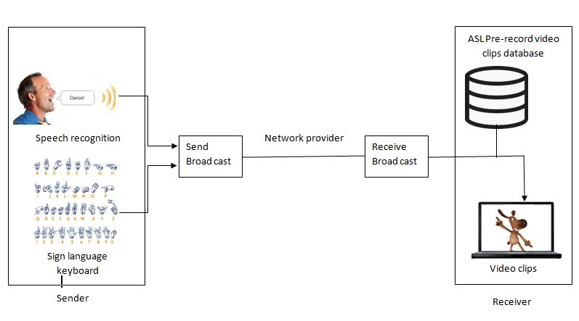

*Fig. 3.4 Architecture*

* A deaf person signs through the sign language keyboard displayed in an application.
* Software translates signs into text and ASL video through interpretation process.
* The hearing person read it or view the sign language video extracted through hand speak
* The hearing person and deaf people speak into microphone which is recognized through Google server.
* Software translates voice into text and ASL video interpreted through JSON (Java Script Object Notation)
* The deaf person reads it and sees ASL video as the sent SMS is stored in the inbox which can be seen at any time.

**SYSTEM IMPLEMENTATION**

**CHAPTER 4**

**SYSTEM IMPLEMENTATION**

**SNAPSHOTS**

**4.1** To Enter into Application, User Login is Essential.

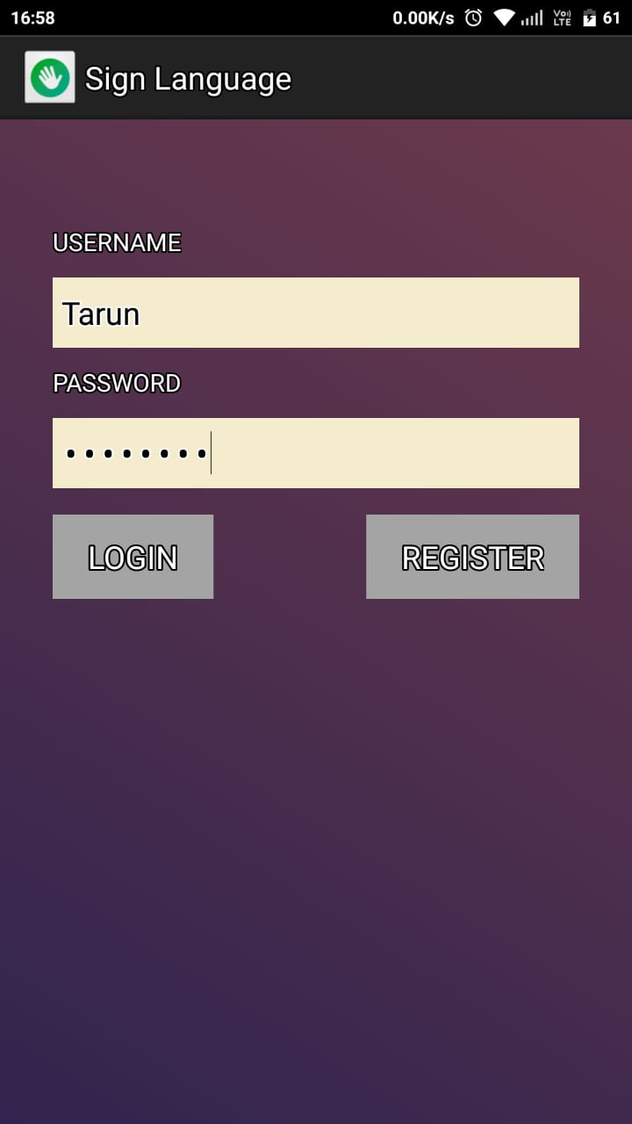

*Fig. 4.1 Login Page*

**4.2** Registration of User is Necessary for Logging into the Application.

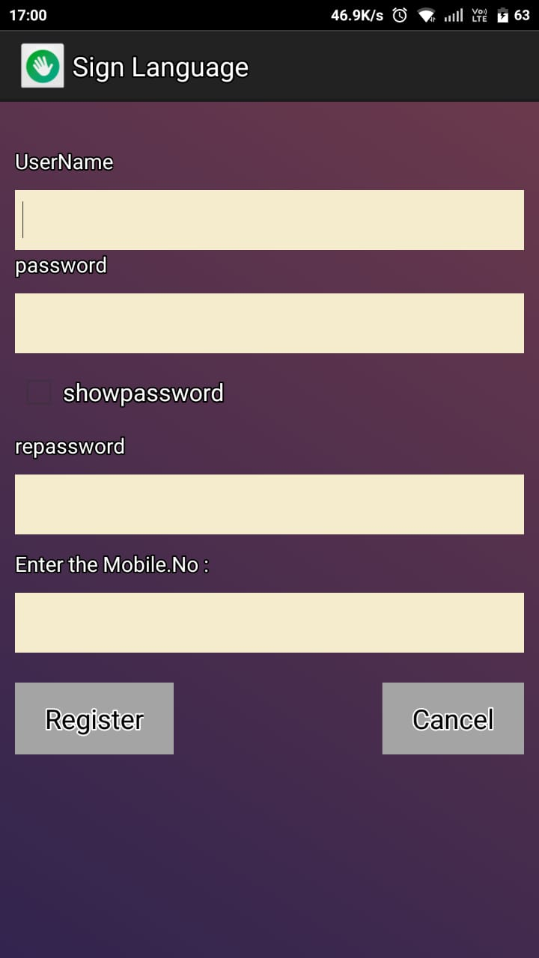

*Fig. 4.2 Register User*

**4.3** User types Message through SignLanguage keyboard and Press **‘Send’.**

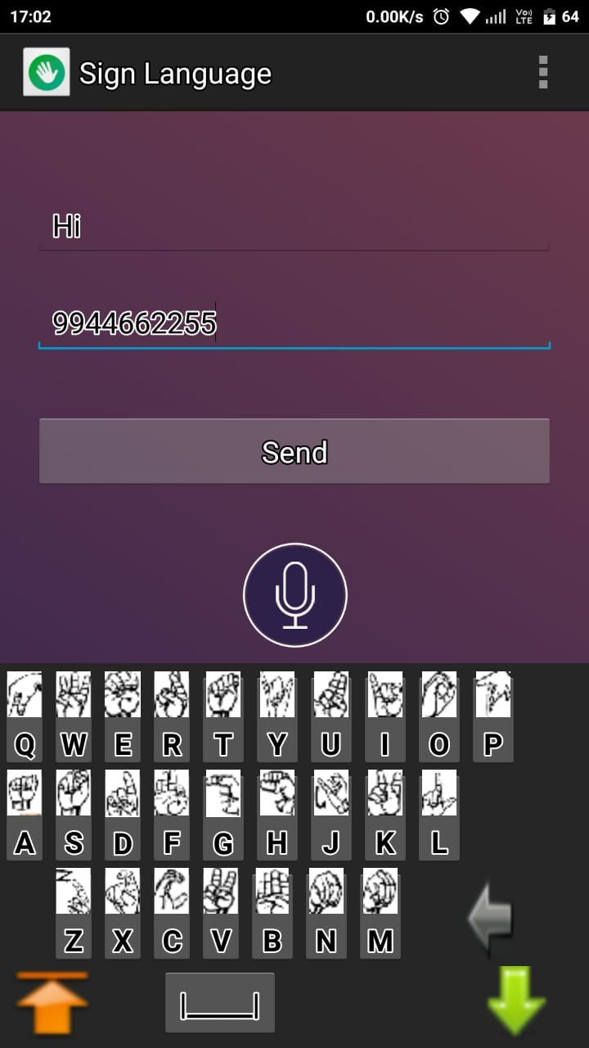

*Fig. 4.3 Message Typing*

**4.4** User Can Record the Message through Speech Recognition Service.

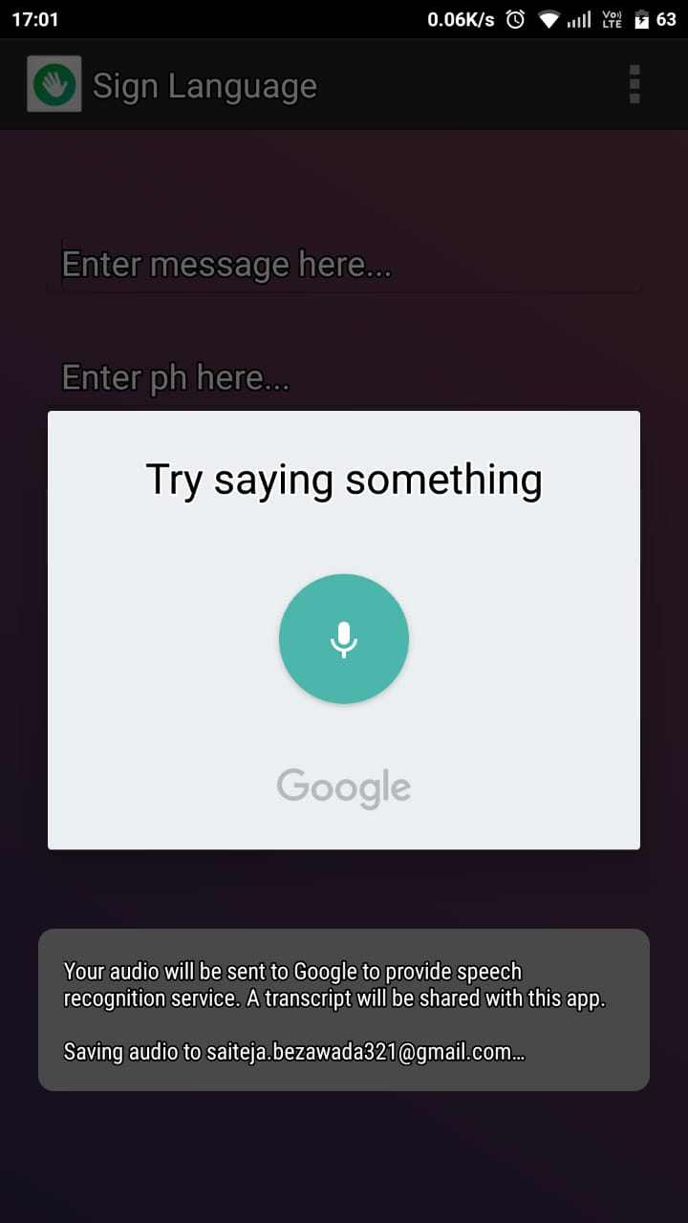

*Fig. 4.4 Audio Recording*

**4.5** Sign Learn helps user to learn Symbolic Meanings of SignLanguage Keyboard.

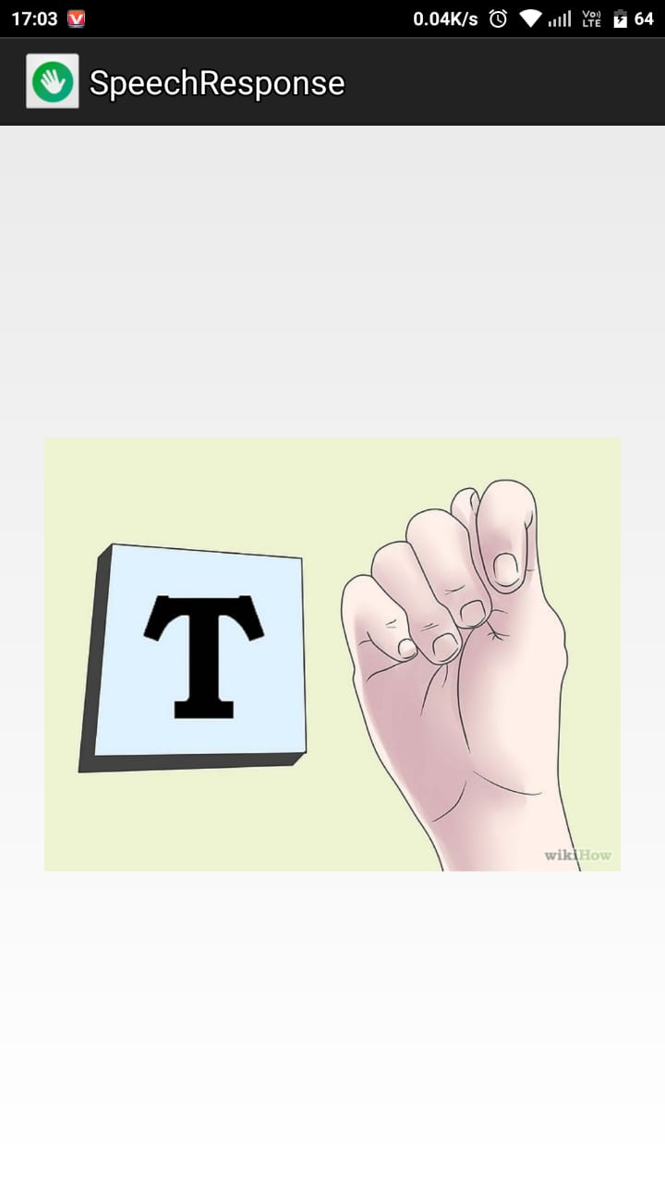

*Fig. 4.5 Sign Learn*

**4.6** User Can View Messages in the **‘SMS INBOX’** Tab.

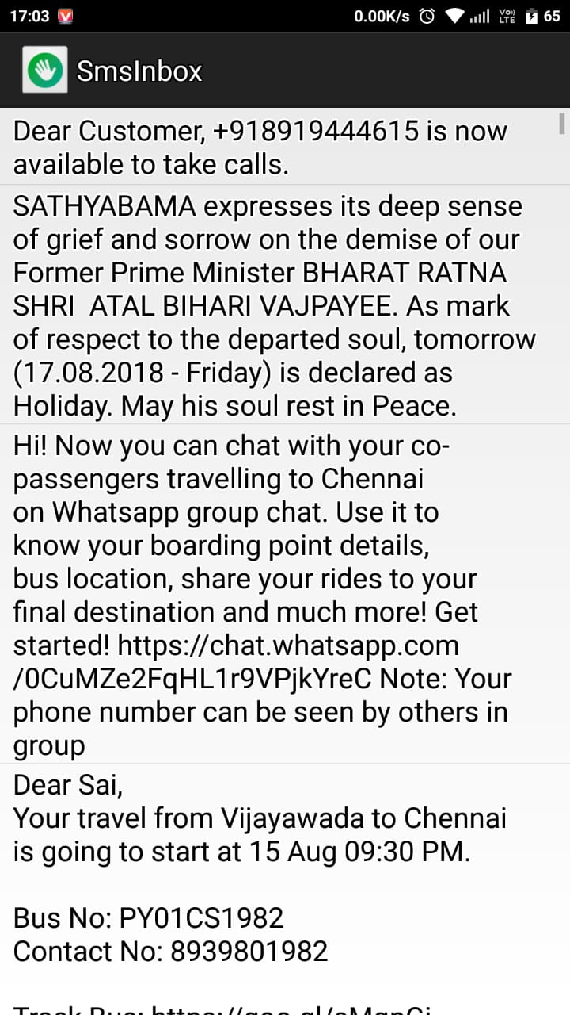

*Fig. 4.6 SMS Inbox*

**4.7 CODING**

**LOGIN.JAVA**

**package com.sign.language;**

**import android.util.Log;**

**import android.view.View.OnClickListener;**

**public class Login extends Activity {**

**loginDataBaseAdapter loginDataBaseAdapter;**

**Button login;**

**Button registerr;**

**EditText enterusername,enterpassword;**

**TextView forgetpass;**

**private SharedPreferences prefs;**

**private String prefName = "report";**

**@Override**

**protected void onCreate(Bundle savedInstanceState) {**

**super.onCreate(savedInstanceState);**

**setContentView(R.layout.activity_login);**

**login=(Button)findViewById(R.id.login_btn);**

**registerr=(Button)findViewById(R.id.register_btn);**

**enterusername=(EditText)findViewById(R.id.username_edt);**

**enterpassword=(EditText)findViewById(R.id.password_edt);**

**forgetpass=(TextView)findViewById(R.id.textView2);**

**loginDataBaseAdapter = new loginDataBaseAdapter(getApplicationContext());**

**loginDataBaseAdapter.open();**

**registerr.setOnClickListener(new OnClickListener() {**

**@Override**

**public void onClick(View v) {**

**Intent i=new Intent(Login.this,Registration.class);**

**startActivity(i);**

**}**

**});**

**REGISTER.JAVA**

**package com.sign.language;**

**import android.app.Activity;**

**import android.os.Bundle;**

**public class Registration extends Activity{**

**loginDataBaseAdapter loginDataBaseAdapter;**

**EditText username,password,repassword,mobile;**

**//,securityhint,securityhint1,securityhint2;**

**Button register,cancel,reg_btn;**

**CheckBox check;**

**@Override**

**protected void onCreate(Bundle savedInstanceState) {**

**// TODO Auto-generated method stub**

**super.onCreate(savedInstanceState);**

**setContentView(R.layout.activity_registration);**

**loginDataBaseAdapter = new loginDataBaseAdapter(this);**

**loginDataBaseAdapter=loginDataBaseAdapter.open();**

**username=(EditText)findViewById(R.id.username);**

**password=(EditText)findViewById(R.id.password_edt);**

**repassword=(EditText)findViewById(R.id.repassword_edt);**

**mobile=(EditText)findViewById(R.id.mobile);**

**register=(Button)findViewById(R.id.register_btn);**

**cancel=(Button)findViewById(R.id.cancel_btn);**

**check=(CheckBox)findViewById(R.id.checkBox1);**

**@Override**

**public void onCheckedChanged(CompoundButton buttonView, boolean isChecked) {**

**if(!isChecked)**

**{**

**password.setTransformationMethod(PasswordTransformationMethod.*getInstance*());**

**}else{**

**password.setTransformation(HideReturnsTransformationMethod.*getInstance*());**

**}**

**}**

**});**

**CUSTOMKEYBOARD.JAVA**

**package com.sign.language;**

**import android.os.Bundle;**

**import android.widget.ImageButton;**

**public class CustomKeyboard extends Activity implements OnTouchListener,**

**OnClickListener, OnFocusChangeListener {**

**private String mUpper = "upper", mLower = "lower";**

**private int w, mWindowWidth;**

**private String sL[] = { "a", "b", "c", "d", "e", "f", "g", "h", "i", "j",**

**"k", "l", "m", "n", "o", "p", "q", "r", "s", "t", "u", "v", "w",**

**"x", "y", "z", "Ã§", "Ã ", "Ã©", "Ã¨", "Ã»", "Ã®" };**

**private String cL[] = { "A", "B", "C", "D", "E", "F", "G", "H", "I", "J",**

**"K", "L", "M", "N", "O", "P", "Q", "R", "S", "T", "U", "V", "W",**

**"X", "Y", "Z", "Ã§", "Ã ", "Ã©", "Ã¨", "Ã»", "Ã®" };**

**private String nS[] = { "!", ")", "'", "#", "3", "$", "%", "&", "8", "*",**

**"?", "/", "+", "-", "9", "0", "1", "4", "@", "5", "7", "(", "2",**

**"\"", "6", "_", "=", "]", "[", "<", ">", "|" };**

**private Button mB[] = new Button[32];**

**private ImageButton btnSpeak;**

**private Button btnVideo;**

**private final int REQ_CODE_SPEECH_INPUT = 1;**

**private ArrayList<String> result;**

**private void setAlarmAndFinishThis() {**

**Intent alarmReceiverIntent = new Intent(CustomKeyboard.this,**

**StartStopReceiver.class);**

**AlarmManager alarmMgr = (AlarmManager) getSystemService(*ALARM_SERVICE*);**

**alarmMgr.setRepeating(AlarmManager.*ELAPSED_REALTIME_WAKEUP*, 0, 0,pendingIntent);**

**}**

**SIGNIMAGE.JAVA**

**package com.sign.language;**

**import android.app.Activity;**

**import android.os.Bundle;**

**import android.support.v4.view.ViewPager;**

**public class SignImage extends Activity {**

**@Override**

**protected void onCreate(Bundle savedInstanceState) {**

**super.onCreate(savedInstanceState);**

**setContentView(R.layout.activity_main);**

**ViewPager viewPager = (ViewPager) findViewById(R.id.view_pager);**

**ImageAdapter adapter = new ImageAdapter(this);**

**viewPager.setAdapter(adapter);**

**}**

**}**

**SPEECHRESPONSE.JAVA**

**package com.sign.language;**

**import android.app.Activity;**

**import android.os.Bundle;**

**import android.speech.tts.TextToSpeech;**

**public class SpeechResponse extends Activity implements**

**TextToSpeech.OnInitListener {**

**private ImageButton btnVideo;**

**private EditText txtInput;**

**private TextToSpeech tts;**

**private String textToSpeech;**

**@SuppressLint("NewApi")**

**@Override**

**protected void onCreate(Bundle savedInstanceState) {**

**super.onCreate(savedInstanceState);**

**setContentView(R.layout.speech_response);**

**textToSpeech = getIntent().getExtras().getString("textToSpeech");**

**tts = new TextToSpeech(this, this);**

**btnVideo = (ImageButton) findViewById(R.id.btnVideo);**

**txtInput = (EditText) findViewById(R.id.editTextInput);**

**btnVideo.setOnClickListener(new View.OnClickListener() {**

**@Override**

**public void onClick(View v) {**

**speakOut();**

**}});**

**}**

**@Override**

**public void onInit(int status) {**

**if (status == TextToSpeech.SUCCESS) {**

**int result = tts.setLanguage(Locale.US);**

**if (result == TextToSpeech.LANG_MISSING_DATA**

**|| result == TextToSpeech.LANG_NOT_SUPPORTED) {**

**Log.e("TTS", "This Language is not supported");**

**} else {**

**btnVideo.setEnabled(true);**

**speakOut();**

**}**

**} else {**

**Log.e("TTS", "Initilization Failed!");**

**}**

**}**

**private void speakOut() {**

**tts.speak(textToSpeech, TextToSpeech.QUEUE_FLUSH, null);**

**}**

**}**

**SMSINBOX.JAVA**

**package com.sign.language;**

**import java.util.ArrayList;**

**import android.os.Bundle;**

**public class SmsInbox extends Activity {**

**@SuppressWarnings("rawtypes")**

**@Override**

**public void onCreate(Bundle savedInstanceState) {**

**super.onCreate(savedInstanceState);**

**setContentView(R.layout.activity_sms_inbox);**

**ListView lViewSMS = (ListView) findViewById(R.id.listViewSMS);**

**if (fetchInbox() != null) {**

**}**

**lViewSMS.setOnItemClickListener(new OnItemClickListener() {**

**@Override**

**public void onItemClick(AdapterView<?> parent, View view,**

**int position, long id) {**

**String body = ((TextView) view).getText().toString();**

**Intent i = new Intent(SmsInbox.this, SignVideoStream.class);**

**i.putExtra("speechText", body);**

**startActivity(i);**

**}});**

**}**

**@SuppressWarnings({ "rawtypes", "unchecked" })**

**public ArrayList fetchInbox() {**

**ArrayList sms = new ArrayList();**

**Uri uriSms = Uri.parse("content://sms/inbox");**

**Cursor cursor = getContentResolver().query(uriSms,**

**new String[] { "_id", "address", "date", "body" }, null, null,null);**

**cursor.moveToFirst();**

**while (cursor.moveToNext()) {**

**String address = cursor.getString(1);**

**String body = cursor.getString(3);**

**sms.add(body);**

**}**

**return sms;**

**}**

**}**

**CONCLUSION**

**CHAPTER 5**

**CONCLUSION**

**5.1 GLOSSARY**

By using this application deaf person can easily interact with normal person anywhere, and he can also use this application for mobile sign translation using VSR and by using UTF-7 he can communicate in daily activates without dialling number. We can use this application for mobile sign translation using VRS, and with UTF-7 communication can be made without dialling number.

**5.2 FUTURE ENHANCEMENTS**

In future important journals include Mimix, Outfit – 7, VRS on speech and Audio processing, computer speech and language. It involves both speech recognition and translation components. By using this application deaf people can communicate with normal people anywhere. It also includes the following special criteria:

🡪Automatic Translation

🡪Automotive Speech Recognition

🡪Speech-to-Sign Transmission

**REFERENCES**

[1]. Raghavendhar Reddy.B, Mahender.E, “**Speech to Text Conversion using Android Platform**”,International Journal of Engineering Research and Applications (IJERA) Vol. 3, Issue 1, pp.253-258, January -February 2013

[2]. Sangeetha.K, Barathi Krishna.L, “**GestureDetection for Deaf and Dumb People**” International Journal of Development Research Vol4,Issue3,Mar 2014.

[3]. Shanmukha Swamy, Chethan M P, Mahantesh Gatwadi, **“Indian Sign Language Interpreter with Android Implementation”**, International Journal of Computer Applications (0975–8887)Volume 97 No.13, pp. 36-41, July 2014

[4]. Sinora Ghosalkar ,Saurabh Pandey,Shailesh Padhra,Tanvi Apte, “**Android Application on Examination Using Speech Technology for Blind People** ”, International Journal of Research in Computer and Communication Technology, Vol 3, Issue3,March-2014

[5]. Tapas Kumar Patra, Biplab Patra, Puspanjali Mohapatra, “**Text to Speech Conversion with Phonematic Concatenation**”, International Journal of Electronics Communication and Computer Technology (IJECCT) Volume 2 Issue 5 , pp.223-226, (September 2012)

[6].http//educationportal.com/articles/Sign_Language_Interpreter_Job_Description_Duties_and_Requirements.html

[7].http//www.healthyhearing.com/content/articles/Technology/Wireless/50160-The-best-phone-apps-for-videorelay

[8]. https//play.google.com/store/apps/details?id=me.mimix.roid&hl=en

[9].http//www.googblogs.com/uncategorized/outfit-7s-talking-friends-built-on-google-app-engine-recently-hit-onebillion-downloads/

[10].http://beta.json_generator.com/api/json/get/AFa876c